Welcome to the challenge of playing an instrument at PPPCS! You will find this class quite challenging at times, but if you complete your homework you will be able to play and instrument and read music…Most people in the world cannot say this, BE PROUD! LET’S GET STARTED!
At the point you have received this material you should be able to make a sound with your instruments mouthpiece. CONGRATULATIONS! This is the first and sometimes the hardest step many students have when starting out on an instrument.
Next, you need to know what all the pieces of your instrument are and how to put it together! Study the parts below and memorize them. There will be a test later!
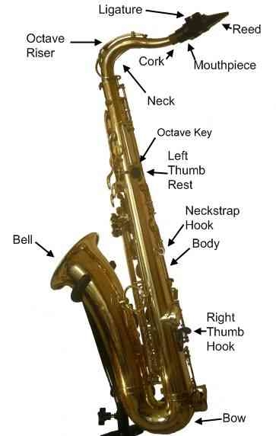
Vocabulary (this will be on your quiz too!)
The Beat – The beat is the pulse of the music.
When we are talking about beat, we are NOT talking about the drum beat. The drum beat is really a rhythm pattern. The beat is where your body moves when you are dancing. If you were dancing exactly where the drums are playing, you would look very funny! We will use a metronome to help us keep a steady beat while we are playing our instruments.
Metronome – A mechanical device that clicks a steady pace.
The metronome is a vital tool when learning music. It keeps a steady beat for musicians to follow. If each member of the wind ensemble is following the same steady beat, the music stays together. If some members are not following that pace, the music becomes very disorganized and doesn’t sound the way it should. We adjust the speed based on how many beats are clicked in one minute. Tempo markings are based on Beats Per Minute (BPM).
Tempo – The speed of music.
Letter names of the staff
Parts of a note
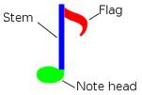
On this page you will see 5 different finger combinations in order to make different sounds on the instrument.

Alto Sax Fingerings for Bb Concert Scale
G1 A2 B3 C4
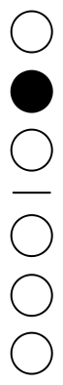

Alto Sax Fingerings for Bb Concert Scale(2)
D5 E6 F7 G8
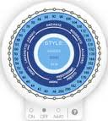

www.metronomeonline.com
Playing Assignment #1

Set your metronome at 60. Start at the top and work your way down the tones. Play each tone for four (4) clicks of the metronome then get your fingers set for the next tone during the next four (4) clicks. Repeat this process until you get to the bottom of the tones. The sound of your instrument should be getting lower as you go down the list. Once are confident you can make it down the list, start at the bottom and work your way up!
The staff is the foundation upon which notes are drawn.
- The modern staff comprises five lines and four spaces.
- Clefs assign individual notes to certain lines or spaces.
- Two clefs are normally used: The Treble and Bass clefs.
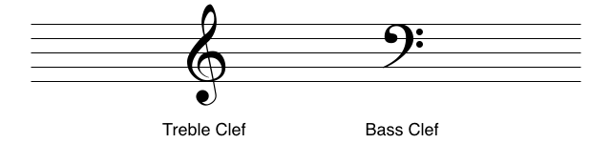

- A ledger line is a small line that extends the staff when we run out of room. With the ledger line drawn, we can place the A.
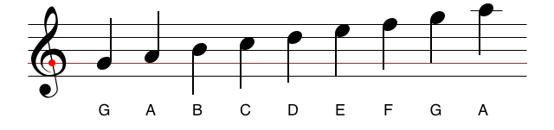
- Vertical black bars called bar lines divide the staff into measures. This staff has been split into two measures.
- Time signatures define the amount and type of notes that each measure contains.
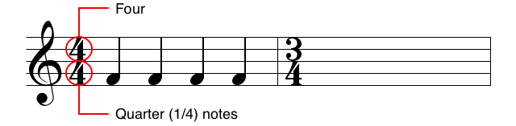
- A key signature is a collection of every accidental found in a scale. To demonstrate this, we will use the key of C Minor, which has three flats. Instead of writing a flat next to every E, A, and B; we can simply add a key signature to the beginning of the measure.

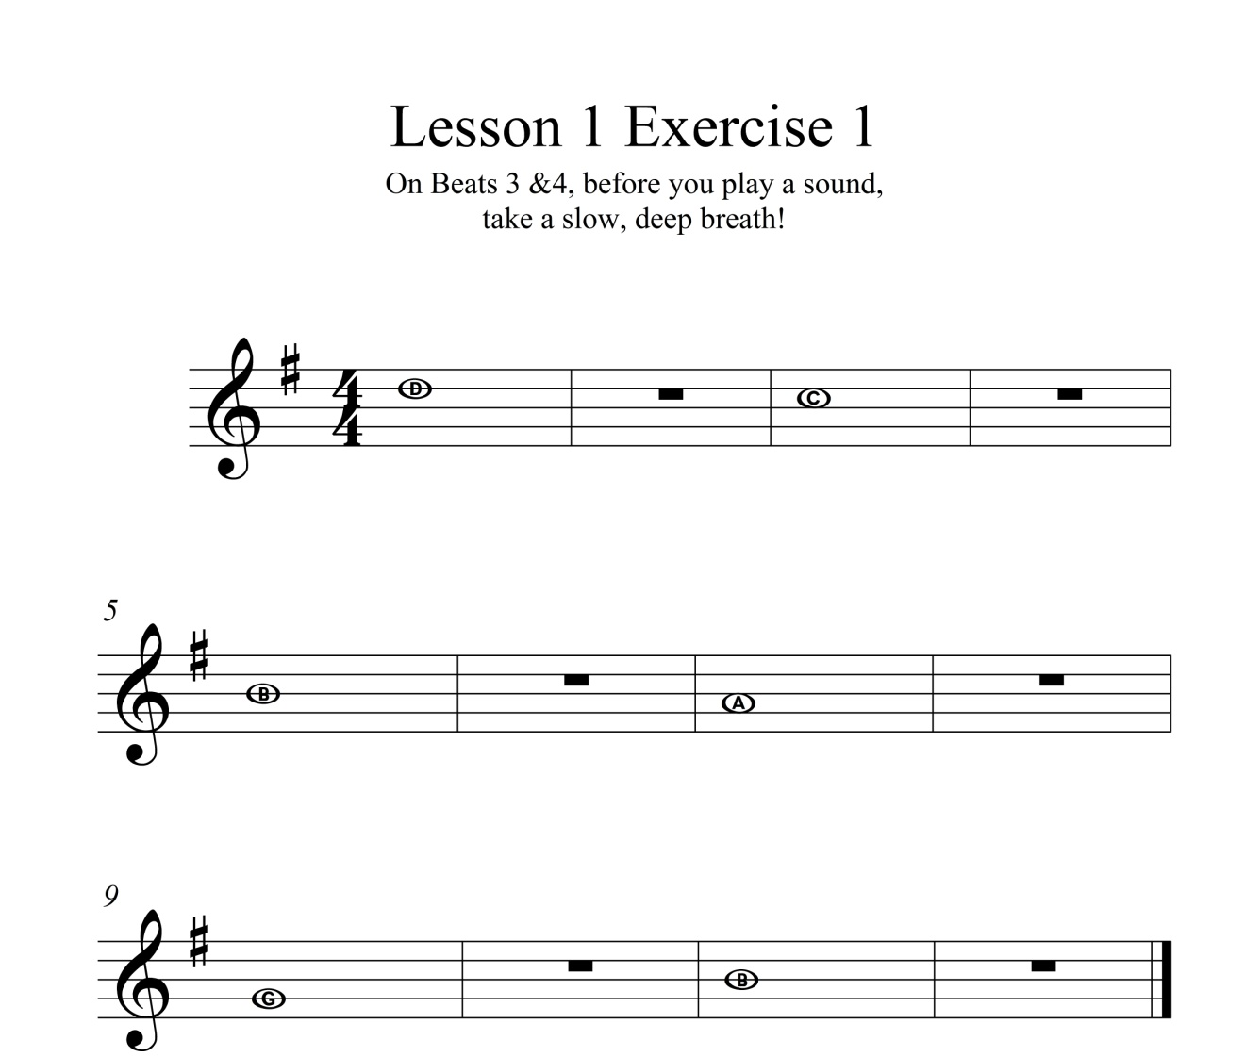
Key Signature – Alto Sax is playing in the key of G. All F’s are sharp (F#).

Treble Clef
Time Signature

Whole Notes receive 4 Beats
(or clicks on the metronome)
Playing Assignment #1

G1 A2 B3 C4 D5
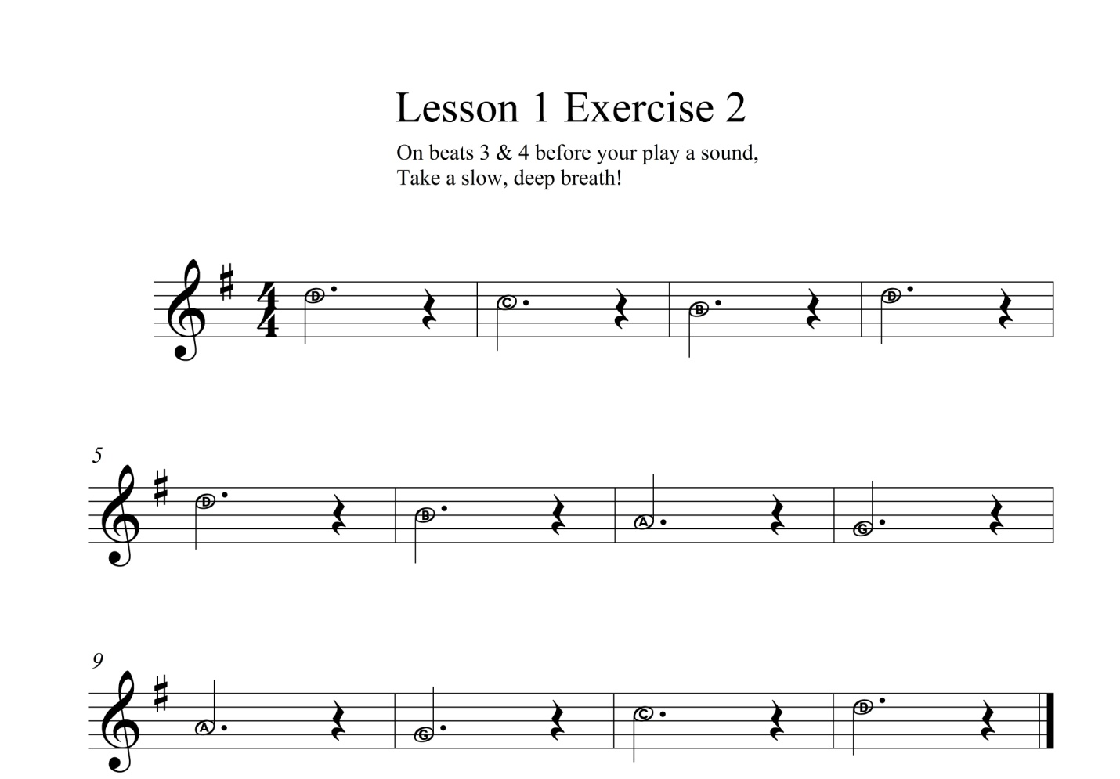
Quarter Rests receive 1 beat
Dotted Half Notes Receive 3 beats
Playing Assignment #2

G1 A2 B3 C4 D5
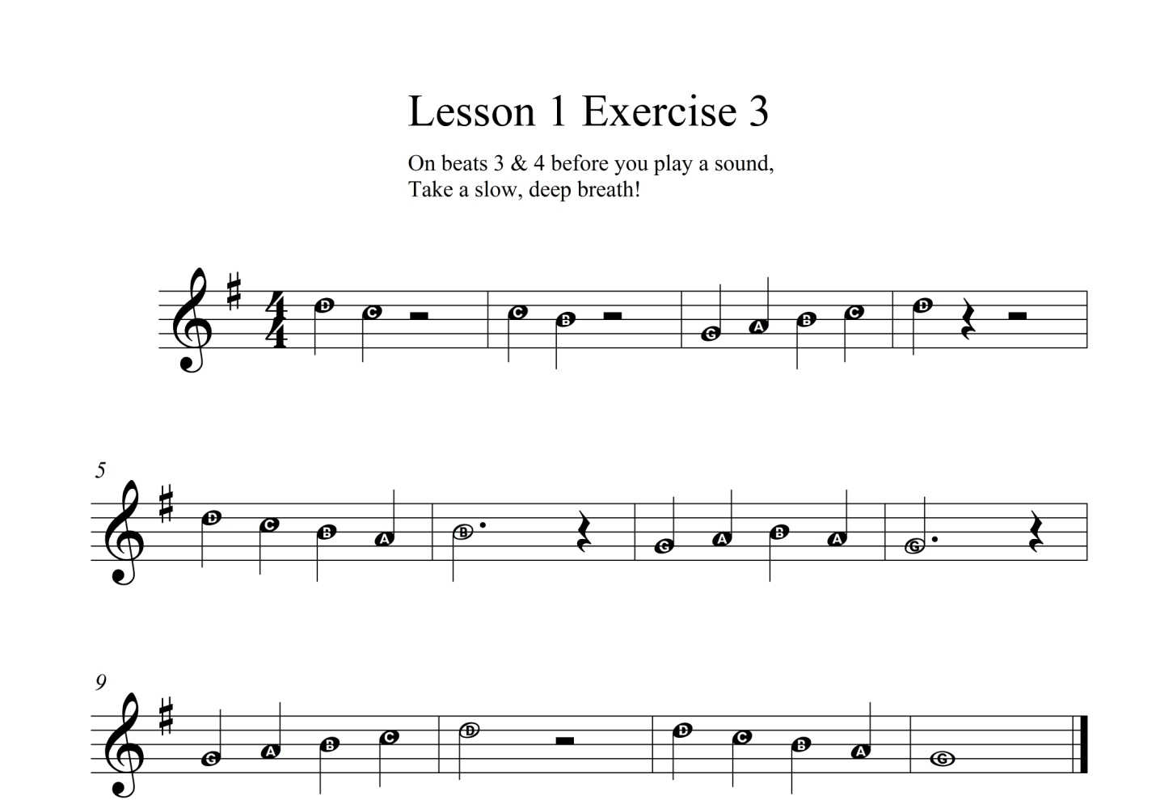
Half Rests receive 2 beats
Quarter Notes receive 1 beat
Playing Assignment #3

G1 A2 B3 C4 D5

All right, we’ve got a few exercises under our belts now. Based on your experiences playing your instrument, describe what has been the hardest part. Use specific details in your answer.

It’s time for you to dip your toes in the pool. You have some experience with Whole Notes, Half Notes, Dotted Half Notes, Half Rests, Quarter Notes and Quarter Rests. WOW, when you look at it like that, you know a lot! Write an eight measure piece of music on the staff below. Use only music symbols, NO LETTERS, and make sure you can play your creation!

3pts – Title/composer written, Music written correctly, no letters written in and student can play the piece.
2pts – Title/composer written, Music written correctly, no letters written in student makes 3 or more mistakes in the piece.
1pt – Music written correctly, letters written in, students makes mistakes while playing.
0pts – No attempt to write or play an original composition.
Double Bar – Tells you this is the end of the song.
Playing Assignment #4

On the next page, you will find a Duet. A duet is a piece of music that has two different parts that are played at the same time. Predict three challenges you may face when playing the duet with a partner.

The commas in the music are breath marks. Take a deep breath once you play the full length of the note!
Playing Assignment #5
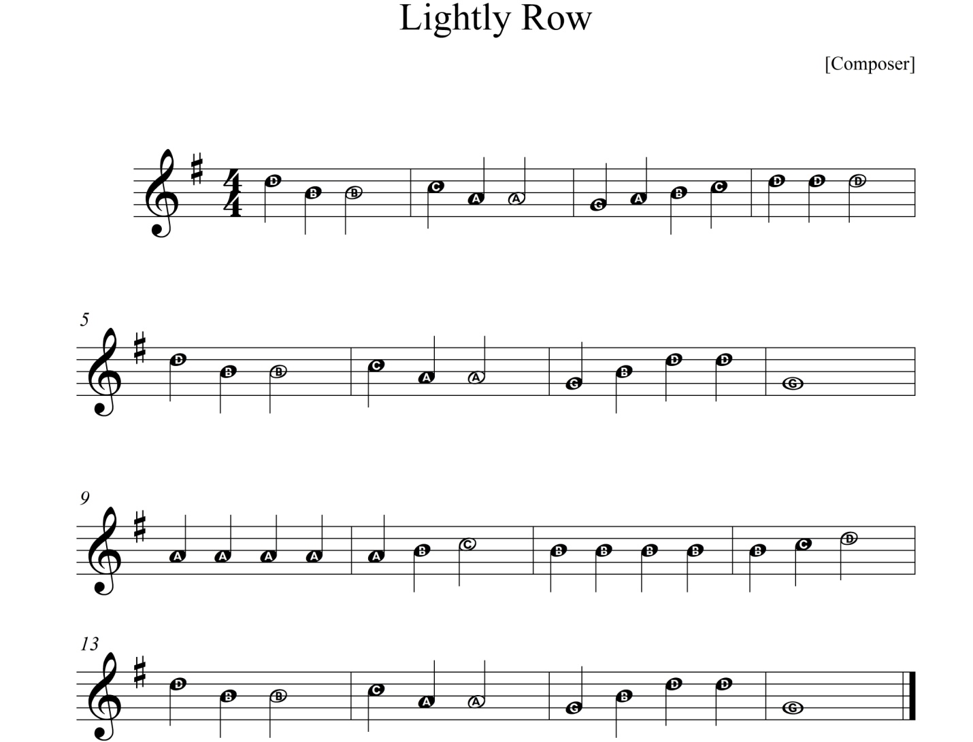
Repeat Sign – Go back to the beginning and play the entire piece twice.
Playing Assignment #6
Write a Twelve measure piece of music on the staff below. Use quarter notes and rests and half notes and rests in YOUR piece. You may only use music symbols, NO LETTERS, and make sure you can play your creation!

3 pts – Title/composer written, Music written correctly, no letters written in and student can play the piece.
2 pts – Title/composer written, Music written correctly, no letters written in student makes 3 or more mistakes in the piece.
1 pt – Music written correctly, letters written in, students makes mistakes while playing.
0 pts – No attempt to write or play an original composition.
New Note! E -
A sits in the second space on the staff and is the 6th note of the Bb scale.
Harmony – Two or more notes played together to form a chord. In other words, these notes will sound good to your ear when they are played at the same time. In our next duet we will produce harmony when we play part 1 and part 2 at the same time!
Playing Assignment #8
Playing Assignment #7
Wolfgang Amadeus Mozart is a legendary operatic composer. What would you like to be known as a legend for, 200 years after your death and how do you think you could achieve that?

Wolfgang Amadeus Mozart (1756-1791) was an Austrian composer and a prodigy piano player. He lived during the time of our Revolutionary War and started playing professionally at age 6! He only lived 35 years, but wrote over 600 pieces of music. His works are described as “melodic” and “imaginative”. He even wrote a piece based on “Twinkle, Twinkle Little Star.”
Playing Assignment #9

Keep your fingers close to the keys and remember to bring the instrument to your body, not the other way around.
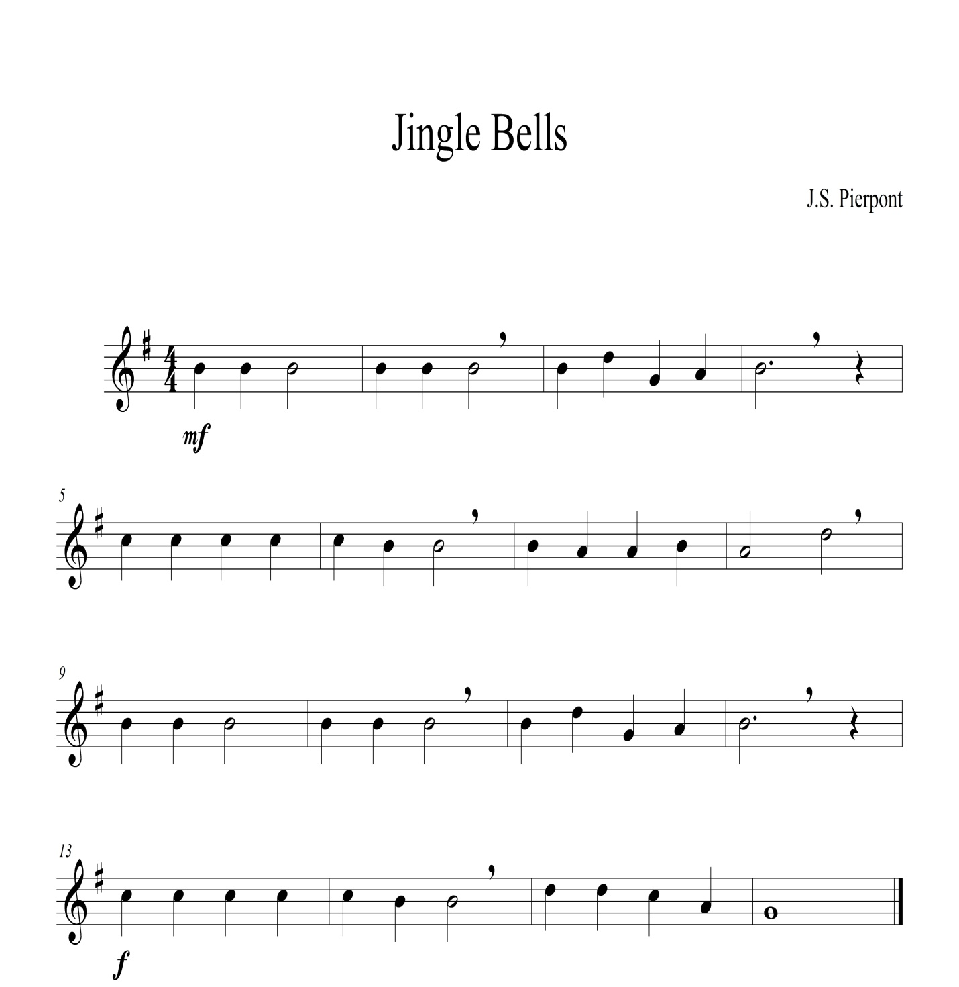
Playing Assignment #10
  (Mezzo Forte) - Medium Loud   (Forte) - Loud

The next piece you are to write must have at least two dynamic changes in the piece. This will give it a little more mood. Use any notation symbols used thus far and create a 12 measure work. You may only use music symbols, NO LETTERS, and make sure you can play your creation and follow the dynamics!

3 pts – Title/composer written, Music written correctly, no letters written in, at least two dynamic changes and student can play the piece.
2 pts – Title/composer written, Music written correctly, no letters written in, at least two dynamic changes and student makes less than 3 more mistakes in the piece.
1 pt – Music written correctly, letters written in, students makes more than more 3 mistakes while playing.
0 pts – No attempt to write or play an original composition.

Playing Assignment #11
         (piano) – soft

Gioacchino Rossini (1792-1868) began writing music as a teenager. He played three instruments piano, viola and horn. He wrote the William Tell Overture as part of his 40th opera!
Listen to the William Tell Overture. Imagine that this music is being used in a movie. Describe in detail the scenery, the characters and what they are doing while this music is being used.

Eight Notes take up only one click. That’s right two sounds in the space of one beat!

Playing Assignment #12

Concert Selections!
Playing Assignment #14
Playing Assignment #13
Playing Assignment #16
Playing Assignment #15
Playing Assignment #18
Playing Assignment #17
Playing Assignment #19
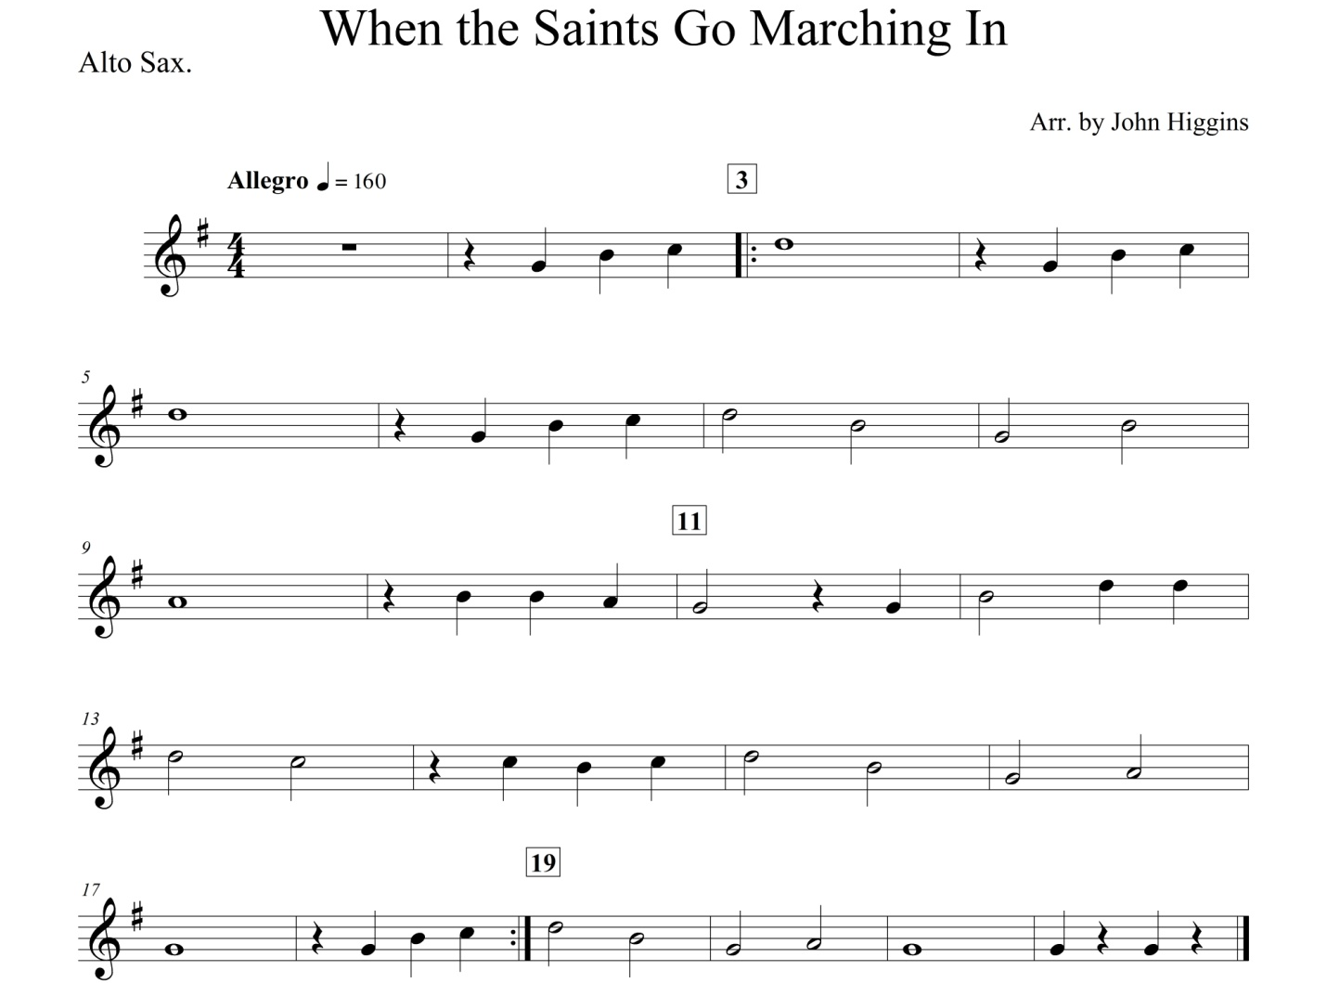
Playing Assignment #20
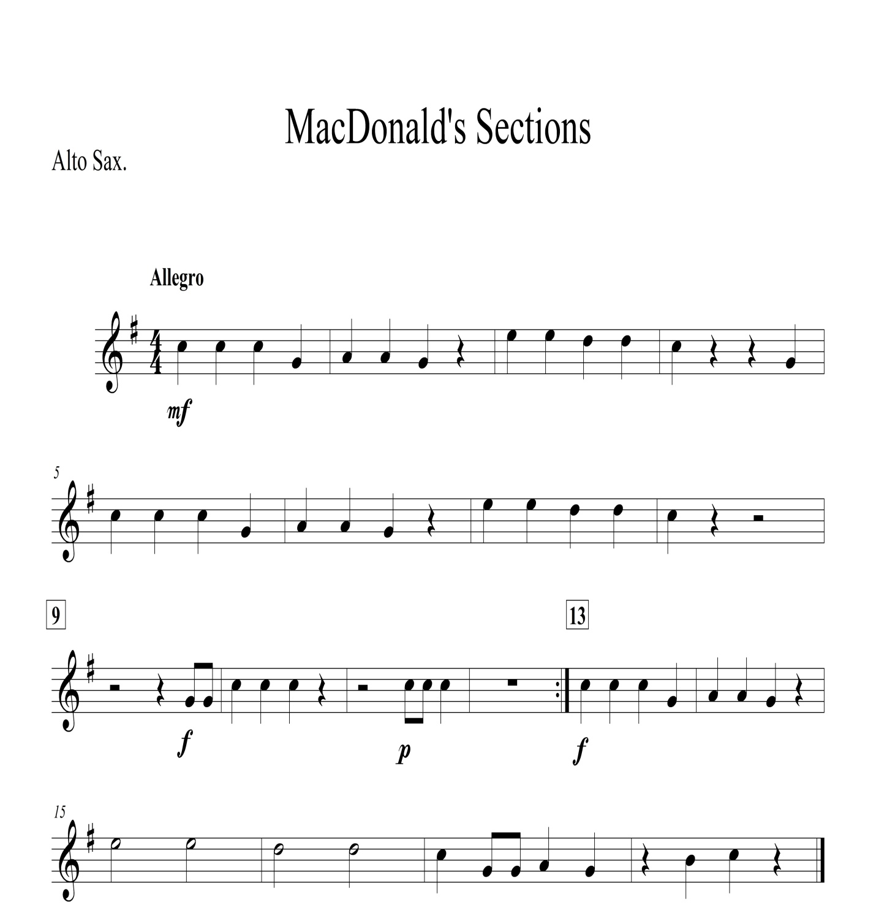
Playing Assignment #21

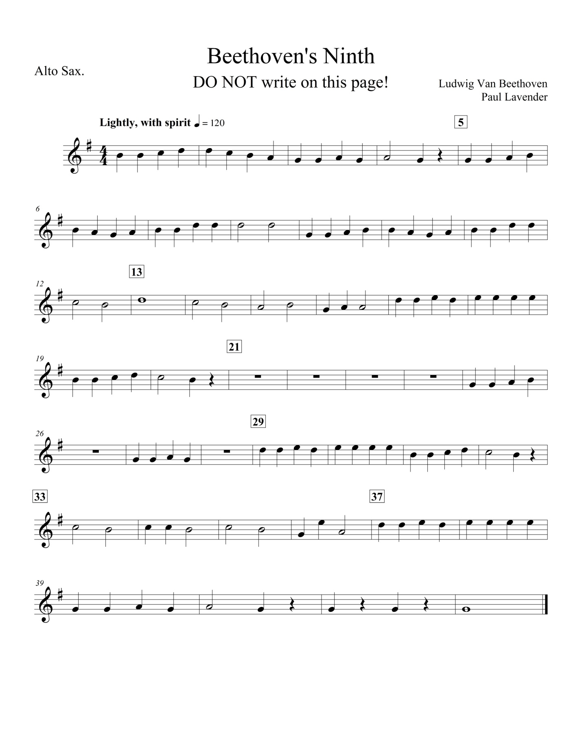
Playing Assignment #22

Playing Assignment #23

